The syntax len( ) lets you get the length of a name characters. Example:
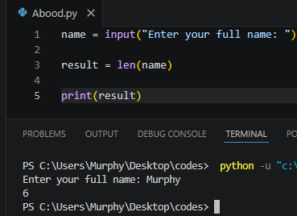
The find method helps you get the first occurrence of a character a position. Example:
Name.find(“ ”)
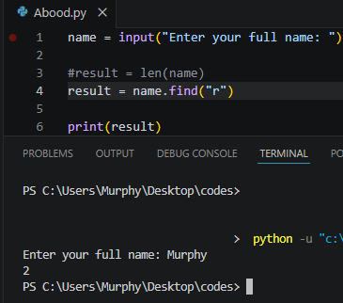
Remember that the first character always has the position number 0 and then the second character starts with 1.

If you need the last occurrence there is a different method which is: rfind(“ ”) The R stands for reverse.
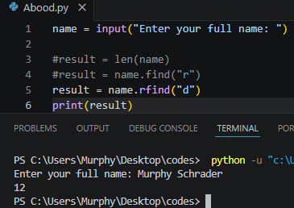
If there are no results python will return negative 1 (-1) because it didn’t find a character.
We can capitalize the first letter of a string using the Capitalize function. Example:
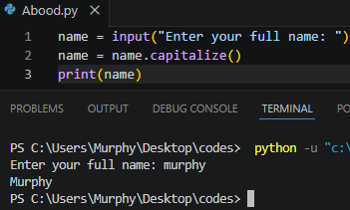
We wrote the name in small letter and the first letter of the name was capitalized.
The upper method will take all the characters in a string and make them uppercase. Example:
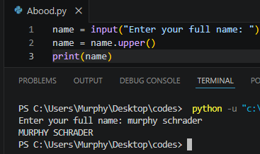
There is also a method to make all the uppercase letter into small letter using the syntax lower. Example:
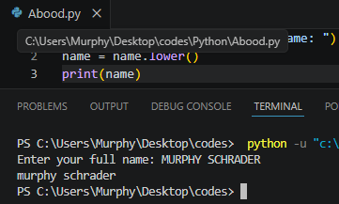
The syntax isdigit will return true or false if a string contains only digits. Example:
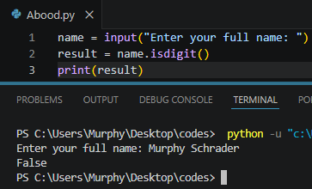
It won’t return true even if out string contains a combination of letter and numbers like Murphy123, It will only return true if it is only digits.
The replace method is one of the useful methods of python, we can replace any occurrence with another. Syntax : .replace Example:
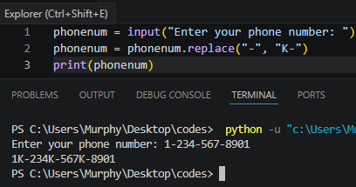
The syntax isalpha( ) allows you to detect if there is a digit in a character. Example:
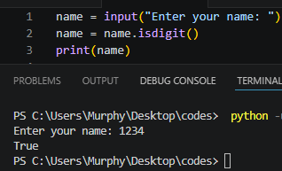
True means that there are digits and false indicates that there are no digits. Another example:
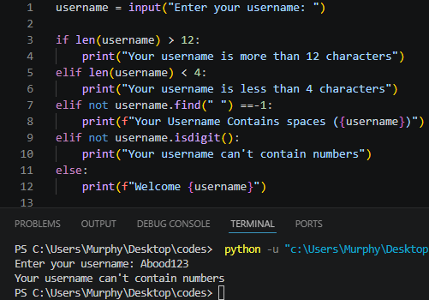

What is string indexing?
Accessing elements of a sequence using [ ] (indexing operator).
(start : end : step)
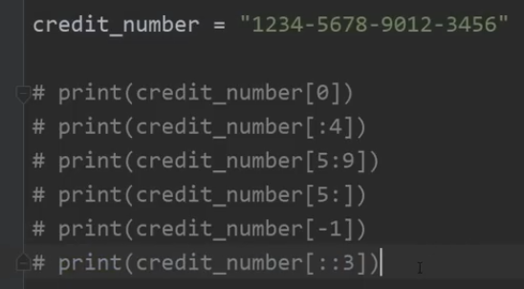
Program about string indexing:
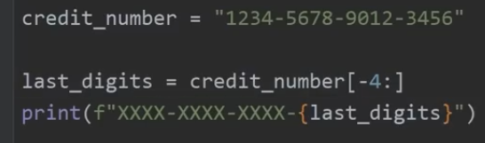
Format Specifier
Format specifiers when used in a context of an f string they allow us to format a value based on what flags are inserted. Examples:
Price1 = 3.14159
Price2 = -987.65
Price3 = 12.34
Print(f”price 1 is {price1}”)
Print(f”price 2 is {price2}”)
Print(f”price 3 is {price3}”)
Within our placeholder, following the value we can add a colon then some flags. Those flags are the format specifiers. They will format our value in a particular way depending on what we insert after the colon. To add a decimal point precision, you will type after the colon dot and then the amount of the decimals to be displayed. Example:
Print(f”price 1 is {price1:.2f}”) The F stands for floating point.

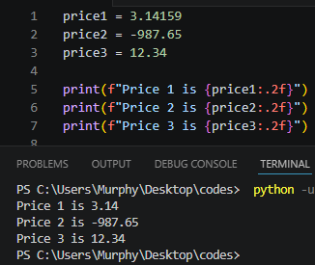
To allocate some space to display a value after the colon, add some number like number 10. Example:
Print(f”price 1 is {price1:10}”)
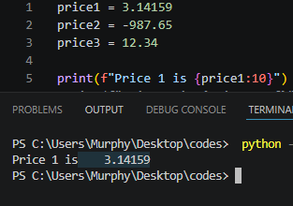
The value now has a total of 10 spaces including the price 3.14159 to display the output.
While Loop
While loop execute some code while some conditions remains true.
We want to let a user enter his name, if he does not enter a name, it must return the message “You did not enter a name” and the program must not exit it will loop the message until the user gives up and enter a name. Example:
Name = input(“Enter Your name”)
While name == “”:
Print(“you did not enter your name.”)
Name = input(“Enter Your name”)

Print(f”Hello {name})

Let’s say we want the user to enter a food they like and when they do, they will be asked again to enter another food they like and to exit the loop they must press Q to exit. Example:

Food = input(“Enter a food you like (Press Q to exit): “)
While not food == “Q”:
Print(f”You like {food})
Food = input(“Enter another food you like (Press Q to exit): “)

Print(“Bye”)

Using logical operators with while

Num = int(input(“Enter a number between 1 – 10) )
While num < 1 or num > 1:
Print(f”{num} is not valid number)
Num = int(input(“Enter a number between 1 – 10) )

Print(f”{num} is your number).

Typecasting
typecasting is the process of converting a variable from one data type to another.
Str() – int() – float() – bool().
Name = “Your name”
Age = 32
Gpa = 3.7
Is_student = True
You could actually the data type of a variable or a value, by using the type(name) function, however when we run this it won’t output anything. So, we are going to use print statement.
Print(type(Name))
Print(type(Age))
Print(type(Gpa))
Print(type(Is_student))
Output should be:
<class ‘str’>
<class ‘int’>
<class ‘float>
<class ‘bool>
Name = “Your name” -- String
Age = 32 -- integer
Gpa = 3.7 – Floating point
Is_student = True – Boolean
Example of how to convert these variables:
Gpa = int(Gpa)
Print(Gpa)
Output: 4
By turning this floating-point number to an integer, it truncated the decimals and only outputted 3.
Age = float(Age)
Print(Age)
Output: 32.0
Age = str(Age)
Print(Age)
Output: 32
After running the code, the result would be the same 32, but it is actually in string and to prove that let’s use the type() function.
Print(type(age)
Now let’s turn the variable Name into a Boolean. Booleans are either True or False
Name = bool(Name)
Print(Name)
Output: True
It doesn’t matter what you type, if you only typed one character The word W it will still show True, but if you don’t type anything it will output False.
We can use this to check if somebody entered their name or not.
Compound interest Calculator
We are going to build a calculator that calculates the interest the bank takes from borrowed money.
The code:
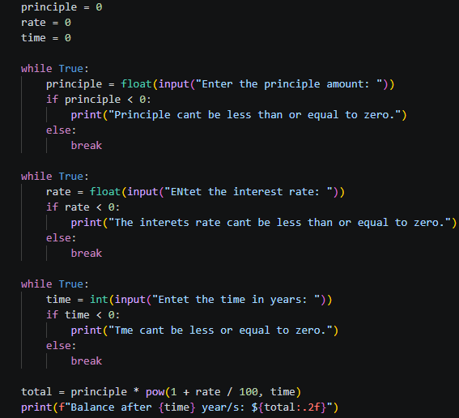
Summary:
We assigned principle, Rate and time with a value of 0.
The user will enter a principle amount something like 500 dollars, and interest rate and also a time the will be in years not in hours.
While True means that it will run forever unless we explicitly break from the loop. We added a Break syntax down at the end of the while.
The total is equals to the principle amount that was entered by the user time 1 + rate divided by 100 and there is the pow function.
The final statement will print the balance after the time which is in years and the total of the money. The (.2f) stands for only print two decimals after the total amount. This help to counter the print of the dozen zeros that has no meaning. This truncates like 10 to 6 decimal portions into just 2 decimals that stands for cents.
After running this we should have our own interest rate calculator in python.

For Loop
For loop will execute a block of code a fixed number of times. You can iterate over a range, string, sequence, etc. Example:
Suppose we need to count to 10, if we where to use a for loop we would something like this;
For x in range() and then what number I like to start from? Let’s say I would like to start from 1 to 10 but the second number is exclusive so we have to write it down as 11. If it is 20 you have to write it as 21 and so on.
for x in range(1, 11):
print(x)
Let’s say we want to count backwards using for loop we are going to use the syntax reversed() so in order to count it backwards like if there was a happy new year event. Example:
For x in reversed(range(1, 6)):
Print(x)
Print(“HAPPY NEW YEAR!)
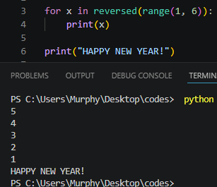
There is an additional parameter you could add and that is the step. If you would like to count by two’s you would add comma the number 2 or any other number if you want to count in 3 then add 3. Example
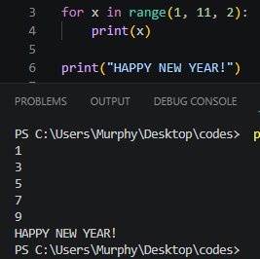
There is some useful keywords ass well these aren’t exclusive to for loop which mean you can use it within while loops too. The syntaxes are: Continue and Break.
Suppose we want to count to 20 and I want to skip the number 13 only and print the rest we would type:
Continue syntax Example:
For x in range(1, 21):
If x == 13:
Continue
Else:
Print(x)
Break syntax Example:
For x in range(1, 21):
If x == 13:
break
Else:
Print(x)
Continue: Skips a number or a statement and continues running the rest of the code.
Break: Stops the program execution as soon as the desired number or statement comes before running it.
Count down timer project
First, we need to import the library called time module. There is a pretty cool function within the Time module that is the Sleep function. Example:
Import time
Time.sleep(3)
Print(“Time’s up”)
The code above explains how to use the sleep function. The set of parenthesis there is a number which is 3, the number stands for 3 second. We simply said we want our program to be asleep for 3 seconds and then after three seconds it will print for us Time’s up. Another example:
My_time = int(input(“Enter the time in seconds: ))
For x in range(0, My_time):
Print(x)
Time.sleep(1)
What if we wanted to count backwards? Of course, you are thinking about the syntax reversed, that is right, but we are going to use step method. Example:
My_time = int(input(“Enter the time in seconds: ))
For x in range(My_time, 0, -1):
Print(x)
Time.sleep(1)
Now let’s display some sort of a digital clock but we will have to calculate how many hours, minutes and seconds there are. Example: let’s start with seconds.
Note: Modules (%) = Returns the remainder of division.
My_time = int(input(“Enter the time in seconds: ))
For x in range(My_time, 0, -1):
Seconds = x % 60
Print(f”00:00:{Seconds}”) # with our digital clock, we can’t go above 60. That is why we are using % 60
Time.sleep(1)
After running the code and entering amount of seconds to count down, it will start counting but we want to add some zero padding.
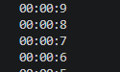
We can do that with a format specifier. After seconds we will add colon and display two digits then zero pad those digits.
Print(f”00:00:{Seconds:02}”) let’s try running it again.
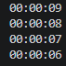
Now let’s move to minutes.
My_time = int(input(“Enter the time in seconds: ))
For x in range(My_time, 0, -1):
Seconds = x % 60
Minutes = int(x / 60) % 60
Print(f”00:{Minutes:02 }:{Seconds:02}”)
Time.sleep(1)
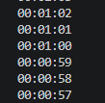
Let’s move to hours.
My_time = int(input(“Enter the time in seconds: ))
For x in range(My_time, 0, -1):
Seconds = x % 60
Minutes = int(x / 60) % 60
Hourse = int(x / 3600) #There is 3600 seconds in an hour, so when u want to run it type 3605.
Print(f”{Hourse:02}:{Minutes:02 }:{Seconds:02}”)
Time.sleep(1)
Nested Loop
Is a loop within another loop (outer, inner). Example:
With a print statement, we end each statement with a newline character. If we need all of these on the same line like a row, at the end of the statement you can add comma end equals empty string.
(,end=” ” | print(x, end=” ”))
Normally with a print statement, each ends with a newline character. But we can set that to something else.
For x in range(1, 11)
Print(x, end=” ”)
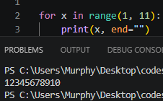
After running the code, we can see all the numbers are now on the same line, or you can add a different simple like dash (-) or a space. Example:
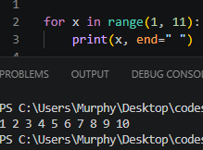  With space | With dash  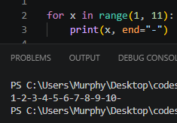
What is we want to repeat this three times? We are going to create another for loop for that. Example:
For y in range(3) #Whatever code is within this loop, will be executed three times.
For x in range(1, 11):
Print(x, end=”-”)
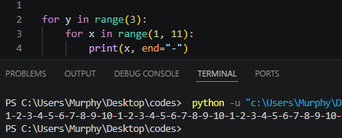
When we ran this, we are completing 30 iterations. Now we need to make each of these numbers or iterations on a completely separate and new lines. So, within the outer loop but not within the inner loop, you are going to create a blank print statement.
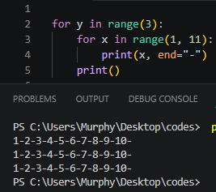
Project with nested loops
We are going to use our previous nested loop with this project.
Row = int(input(“Enter a number of rows: ))
column = int(input(“Enter a number of column: ))
symbol = input(“Enter a symbol to use: )
For y in range(rows)
For x in range(columns):
Print(symbol, end=”-”)
Print()
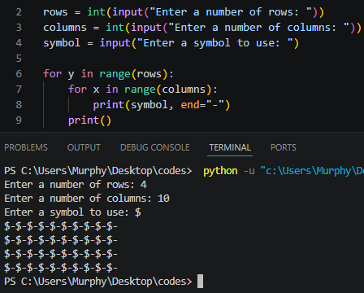

Collection
Collections are a single variable used to store multiple values.
There are four general purpose collections three of them are: -
- List: [ ] ordered and changeable, Duplicates OK
- Set: { } unordered and immutable, but add/remove Ok. No duplicates.
- Tuple: ( ) ordered and unchangeable. Duplicates OK. Faster.
There are also dictionaries but we will get into that in a later lesson.
Let’s say we have a variable with the name “fruits” and I will assign it with a value of apple.
We can turn this variable into a collection by surrounding my values with either; list, set and tuple.
If we would like to store more than one value, we will surround our value with [ ] and then we can store multiple values separated by a comma. Example:
Fruits = [“apple”, “orange”, “banana”, “coconut”]
Print(fruits)
To access one of these fruits, you need to use the index operator. The first element will have an index of zero, the second first and so on.
Fruits = [“apple”, “orange”, “banana”, “coconut”]
Print(fruits[0])
Let’s say we would like to print only the first 3 fruits we would type 0:3 or :3 in the print statement.
Print(fruits[0:3])
We could even use step.
Print(fruits[::2])
Output: Apple, banana
We would like our fruits backwards.
Print(fruits[::-1])
Output: Coconut, banana, orange, apple
Another thing you can do with collection is that you can iterate over them with the for loop. Example:
For x in fruits:
Print (x)
To list the different methods that are available to a collection you can use the dir() function. Example:
Print(dir(fruits))
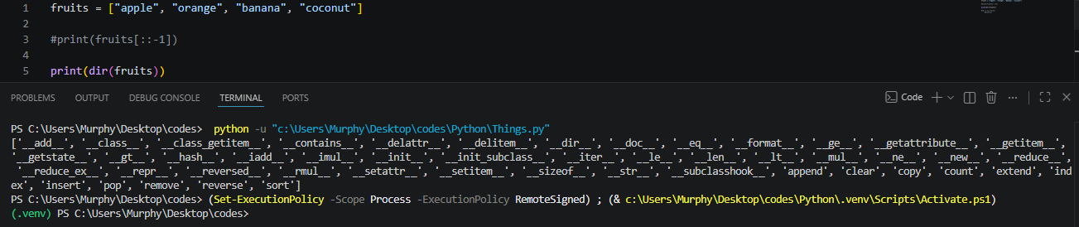
Using the length function to get the list number of fruits. Example:
Print(len(fruits))
Output: 4
Using the In operator we can find if a value is within a collection. Example:
print(“apple” in fruits)
we can change of the values above after we create our list. Example:
print(fruits [0] = “pineapple”)
for x in fruits:
print(x)
Some methods found within a list:
To add an element to the end of the list use the append() method.
Fruits.append(“pineapple”)
Print(fruits)
To remove an element the remove() method.
Fruits.remove(“apple”
Print(fruits)
Using the insert() method, we can insert an element in a given index:
Fruits.insert(0, “pineapple”)
Print(fruits)
The sort() method will sort a list in alphabetical order:
Fruits.sort( )
Print(fruits)
To reverse a list, you will use the reverse() method:
Fruits.reverse()
Print(fruits)
To clear the list, use the clear() method:
Fruits.clear()
Print(fruits)
To return the index of a value. Let’s return the index of apple:
Print(fruits.index(“apple”)
Output: 0
You can count how many elements within a list using the count() method:
Print(Fruits.count(“banana”))
Now let’s talk about the next collection which is set, to create a set surround your values with curly brackets { }. Example:
Fruits = {“apple”, “orange”, “banana”, “coconut”}
Let’s use the add() method to add pineapple:
Fruits.add(“pineapple”)
Print(fruits)
we can remove an element using the remove() method:
fruits.remove(“apple”)
print(fruits)
The pop() method will remove whatever element is first, but it is going to be random.
fruits.pop()
print(fruits)
Lastly, let’s talk about tuples. A tuple is collection that is surrounded with a set of parenthesis ( ). Tuples are ordered and unchangeable but can be duplicated and it is faster than lists.
Fruits = (“apple”, “orange”, “banana”, “coconut”, “apple”)
There are only two methods we have access two and they are:
The index() method
Print(Fruits.index(“apple”))
The count() method
Print(Fruits.count(“apple”))
Output: 2
Shopping Cart Program
foods = []
prices = []
total = 0

while True:
food = input("Enter a food to buy (Press Q to Quit): ")
if food.lower() == "q":
break
else:
price = float(input(f"Enter the price of {food} $: " ))
foods.append(food)
prices.append(price)

print("-" * 15, "Your cart", "-" * 15)

for food in foods:
print(food)

print("-" * 15, "Prices", "-" * 15)

for price in prices:
total += price
print(price)

print("---Total Price are: ---")
print(f"Your total is: {total}")

while True:
user = input("Would like to get a receipt? (Yes or No): ")
if user.lower() == "yes":
print("Thank you for shopping with us. Have a nice day")
print("-" * 50)
print("")
print("")
print("-" * 15, "Items Bought", "-" * 15)
print(foods)
print("-" * 15, "Prices", "-" * 15)
print(prices)
print("-" * 15, "Total Price", "-" * 15)
print(f"Your total is: {total}")
break
else:
print("Thank you for shopping with us. Have a nice day")
break

Two dimensional Lists (2D Lists)
Two-dimensional list is just a list made up of lists. It is useful if you ever needed a grid or matrix of data just like in Excel spreadsheet.
Fruits = [“apple”, “orange”, “banana”, “coconut”]
Vegetables = [“celery”, “Carrots”, “potatoes”]
Meats = [“chicken”, “fish”, “turkey”]
Groceries = [fruits, vegetables, meats]
Print(Groceries[0])
If we where to print groceries at index 0 in place of returning one element found withing one of the lists, that would return the entire row of fruits. So, groceries at index 0 is our fruits list, at index 1 is vegetables list and at index 2 are meats list.
For one of the elements found within one of the rows you would need two indices. If we want to print the apple within the fruits list only, we would type: -
Print(Groceries[0][0]) row zero, column zero that would be apple. Row zero column one that would be orange and so on.
Now let’s create a keypad that found on phone. We need three data types: - a list, a set or a tuple. The elements are unordered so we can’t use that. A tuple is faster than list. A tuple is ordered and unchangeable so we should use it.
Num_pad = ( (1,2,3),(4,5,6),(7,8,9 ),(“*”, 0 , “#” ) ) in this case num_pad is 2D tuple. Let’s use for loop to iterate over every row.
for row in num_pad:
print(row)
we are printing every row in our num_pad but we would like to remove the set of parenthesis. Let’s create a nested loop.
for row in num_pad:
for num in row:
print(num, end= “ ”)
print()
Quiz Game
questions = ("How many elements are in the periodic table?: ",
"Which animal lays the largest eggs?: ",
"What is the most abundant gas in earth's atmosphere?: ",
"How many bones are in the human body?: ",
"Which planet in the solar system is the hottest?: ")

options = (
("A. 116 ","B. 117 ","C. 118 ","D. 119 "),
("A. Whale ","B. Crocodile ","C. Elephant ","D. Ostrich "),
("A. Nitrogen ","B. Oxygen ","C. Carbon-Dioxide ","D. Hydrogen "),
("A. 206 ","B. 207 ","C. 208 ","D. 209 "),
("A. Mercury ","B. Venus ","C. Earth ","D. Mars ")
)

answers = ("C","D","A","A","B")
guesses = []
score = 0
question_num = 0

for question in questions:
print("-" * 50)
print(question)

for option in options[question_num]:
print(option)

guess = input("Enter (A, B, C, D): ").upper()
guesses.append(guess)
if guess == answers[question_num]:
score += 1
print("correct")
else:
print("Incorrect")
print(f"{answers[questions_num]}is the correct answer")
question_num += 1

print("---------------------------")
print(" Results ")
print("---------------------------")

print("Answers: ", end="")
for answer in answers:
print(answer, end=" ")
print()

print("guesses: ", end="")
for guess in guesses:
print(guess, end=" ")
print()

score = int(score / len(questions) * 100)
print(f"Your score is {score}%")

Another version but with grading system using if and else statements
questions = ("How many elements are in the periodic table?: ",
"Which animal lays the largest eggs?: ",
"What is the most abundant gas in earth's atmosphere?: ",
"How many bones are in the human body?: ",
"Which planet in the solar system is the hottest?: ")

options = (
("A. 116 ","B. 117 ","C. 118 ","D. 119 "),
("A. Whale ","B. Crocodile ","C. Elephant ","D. Ostrich "),
("A. Nitrogen ","B. Oxygen ","C. Carbon-Dioxide ","D. Hydrogen "),
("A. 206 ","B. 207 ","C. 208 ","D. 209 "),
("A. Mercury ","B. Venus ","C. Earth ","D. Mars ")
)

answers = ("C","D","A","A","B")
guesses = []
score = 0
question_num = 0

for question in questions:
print("-" * 50)
print(question)

for option in options[question_num]:
print(option)

guess = input("Enter (A, B, C, D): ").upper()
guesses.append(guess)
if guess == answers[question_num]:
score += 1
print("correct")
else:
print("Incorrect")
print(f"{answers[question_num]} is the correct answer")
question_num += 1

print("---------------------------")
print(" Results ")
print("---------------------------")
print()
print("Answers: ", end="")
for answer in answers:
print(answer, end=" ")
print()

print("guesses: ", end="")
for guess in guesses:
print(guess, end=" ")
print()

score = int(score / len(questions) * 101)
print(f"Your score is {score}%")
if score == 100:
print("Your grade is A")
elif score > 100:
print("Your grade is A+")
elif score == 80:
print("Your grade is B")
elif score == 60:
print("Your grade is C")
elif score == 50:
print("Your grade is D")
elif score == 40:
print("Your grade is E")
elif score == 20:
print("Your grade is F")
elif score == 0:
print("Have you ever went to school buddy?")
else:
print("Invalid Credentials")

Dictionary
A collection of {key:value} pairs they are ordered and changeable. No duplicates allowed.
We will use countries and their capitals as an example:
capitals = {"USA":"Washington D.C.",
"India":"New Delhi",
"Somalia":"Mogadishu",
"Saudi Arabia":"Riyadh"}

print(capitals.get("Somalia"))

we can also use if and else statements with it:

if capitals.get(“Somalia”):
print(“That capital exists”)
else:
print(“That capital doesn’t exist”)

we can add another key and a value or update an existing key and a value using the syntax Update(). Example:

Adding a key and a value:
capitals.update({“Germany”:”Berlin”})
print(capitals)
Updating an existing key and value:
capitals.update({“USA”:”New York”})
print(capitals)

To remove a key value, you can use the syntax pop() method. Example:

Capitals.pop(“USA”)
print(capitals)
We can remove the latest key value inserted using the syntax popitem(). Example:
Capitals.popitem()
print(capitals)
Note: You don’t have to pass anything inside of the parenthesis
To get all of the keys within the dictionary but not their values you can use the syntax keys(). Example:
Keys = capitals.keys()
print(Keys)
Output: dict_keys(['USA', 'India', 'Somalia', 'Saudi Arabia', 'Germany']).
We can also use that in a for loop. Example:
For key in capitals.keys():
Print(key)
We can also get all the values within the dictionary without the keys using the syntax value(). Example:
Values = capitals.values()
Print(Values)
Output: dict_values(['Washington D.C.', 'New Delhi', 'Mogadishu', 'Riyadh', 'Berlin']).
We can also use that in a for loop. Example:
For value in capitals.values():
Print(value)
The items() method returns a dictionary object which resembles a 2D list of tuples. Example:
Items = capitals.items()
Print(Items)
Output: dict_items([('USA', 'Washington D.C.'), ('India', 'New Delhi'), ('Somalia', 'Mogadishu'), ('Saudi Arabia', 'Riyadh'), ('Germany', 'Berlin')]).
We can also use it in a for loop. Example:
For key, value in capitals.items():
Print(f”{key}:{value}”)
Random Number Generator
First, we are going to import the random library.
Import random
Let’s say we want a random whole number like a dice, it consists of 6 numbers. We are going to use the syntax called random.randint() for this because it gives us a random integers.
Number = random.randint(1,6)
Print(Number)
Every time you run the program you get a random number between 1 and 6. You can also pass variables.
Low = 1
High = 100
Number = random.randint(Low, High)
Print(Number)
You asked the program to give you a random number between 1 and 100.
You can also choose a random string something like rock, paper and scissors using the sysntax random.choice().
Opt = (“rock”, “Paper”, “scissors”)
Option = random.choice(opt)
Print(Option)
Every time you run it; you get rock, paper and scissor randomly.
If you want to shuffle number, word, letters and names; you can use the shuffle method. Syntax: random.shuffle()
Cards = [“1”, “2”, “3”, “4”, “5”, “6”, “7”, “8”, “9”, “10”, “J”, “Q”, “K”, “A”, “Abood”]
Random.shuffle(Cards)
Print(Cards)
Every time you run the code shuffle the numbers, letters and the names together.
Number Guessing game
is_running = True
print("-----Welcome to the game-----")
print(f"select a number between {lown} and {highn}")
while is_running:
guess = input("Enter your guess: ")
if guess.isdigit():
guess = int(guess)
guesses += 1 # Adds 1 to every wrong guess until it is correct
if guess < lown or guess > highn:
print("That number is out of range.")
print(f"Please select a number between {lown} and {highn}")
elif guess < ans:
print("Too low try again.")
elif guess > ans:
print("Too high try again.")
else:
print(f"Correct the answer was: {ans}")
print(f"Number of guesses: {guesses}")
is_running = False # To escape from the loop
else:
print("Invalid Guess.")
print(f"Please select a number between {lown} and {highn}")

Rock, Paper and Scissors game
import random
opt = ("rock", "paper", "scissors")
points = 0
running = True
while running:
player = None
computer = random.choice(opt)
while player not in opt: # While the player is not picking one of our choices within opt it will continue forever
#once the player picks something within opt then the player will be able to escape the while loop.
player = input("Enter a choice (rock, paper, scissors): ").lower()
print(f"Player: {player}")
print(f"Computer: {computer}")
if player == computer:
print("It's a tie!")
print("-" * 12)
print("Press Q to quit")
print("-" * 12)
print(f"Your points are: {points}")
elif player == "rock" and computer == "paper":
print("You Lose!")
print("-" * 12)
print("Press Q to quit")
print("-" * 12)
print(f"Your points are: {points}")
elif player == "paper" and computer == "rock":
print("You Win!")
points += 1
print("-" * 12)
print("Press Q to quit")
print("-" * 12)
print(f"Your points are: {points}")
elif player == "scissors" and computer == "paper":
print("You Win!")
points += 1
print("-" * 12)
print("Press Q to quit")
print("-" * 12)
print(f"Your points are: {points}")
elif player == "scissors" and computer == "rock":
print("You Lose!")
print("-" * 12)
print("Press Q to quit")
print("-" * 12)
print(f"Your points are: {points}")
elif player == "rock" and computer == "scissors":
print("You Win!")
points += 1
print("-" * 12)
print("Press Q to quit")
print("-" * 12)
print(f"Your points are: {points}")
elif player == "paper" and computer == "scissors":
print("You Lose!")
print("-" * 12)
print("Press Q to quit")
print("-" * 12)
print(f"Your points are: {points}")
playag = input("Would you like to play again? (y/n): ").lower()
if not playag == "y":
running = False
# this will exit the while loop if the player enters y the game will continue if he enters something other than Y
#the game will stop

Dice roller program
import random
# ● ┌ ─ ┐ │ └ ┘
"┌─────────┐ "
"│ │ "
"│ │ "
"│ │ "
"└─────────┘ "
dice_art = {
1: ("┌─────────┐ ",
"│ │ ",
"│ ● │ ",
"│ │ ",
"└─────────┘ "),
2: ("┌─────────┐ ",
"│ ● │ ",
"│ │ ",
"│ ● │ ",
"└─────────┘ "),
3: ("┌─────────┐ ",
"│ ● │ ",
"│ ● │ ",
"│ ● │ ",
"└─────────┘ "),
4: ("┌─────────┐ ",
"│ ● ● │ ",
"│ │ ",
"│ ● ● │ ",
"└─────────┘ "),
5: ("┌─────────┐ ",
"│ ● ● │ ",
"│ ● │ ",
"│ ● ● │ ",
"└─────────┘ "),
6: ("┌─────────┐ ",
"│ ● ● │ ",
"│ ● ● │ ",
"│ ● ● │ ",
"└─────────┘ ")
}
dice = []
total = 0
num_of_dice = int(input("How many dice?: "))
for die in range(num_of_dice):
dice.append(random.randint(1, 6))
for die in range(num_of_dice):
for line in dice_art.get(dice[die]):
print(line)
for die in dice:
total += die
print(f"total: {total}")

pagain = input("Would u like to roll a dice again? (Y/N): ").lower()
if not pagain == "y":
running = False

Functions
Is a block of reusable code. To invoke a function, you place a set of parenthesis () after the function name to invoke it.
If you wanted to repeat a “happy birthday song” without typing it three times you are going to use the syntax def(): Example:
Def Happy():
Print(“Happy Birthday To you!”)
Print(“You are old!”)
Print(“Happy Birthday To you!”)
Print()

Happy()
Happy()
Happy()

To invoke a function, you just type the function name in our case it is Happy and then add a set of parenthesis. You call a function to invoke it.
With functions you can send a data straight to a function using one are known as “Arguments” you can send values or variables directly to a function. Example:
Def Happy(name):
Print(f“Happy Birthday To {name}!”)
Print(“You are old!”)
Print(“Happy Birthday To you!”)
Print()

Happy(“Abood”)
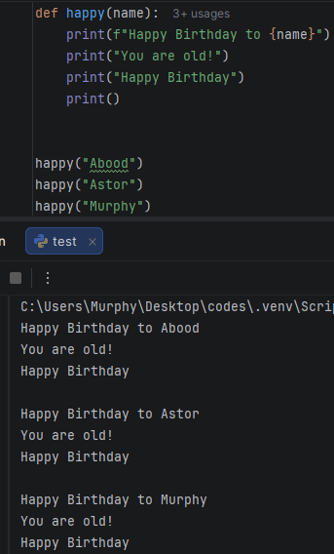
You can send more than one argument like age.
Our function first must be set up to take two arguments, in our case we set a name and age.
Def Happy(name, age):
Print(f“Happy Birthday To {name}!”)
Print(f“You are {age} years old!”)
Print(“Happy Birthday To you!”)
Print()

Happy(“Abood”, 24)
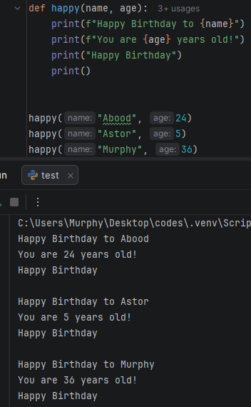
The order does matter you can’t just switch between name and age and make them age and name, that will switch positions too.
You can use the syntax Return to send a result back to the caller and to end function. Example:
def name(first,last):
first = first.capitalize()
last = last.capitalize()
return first + " "+ last
full = name("abood", "murphy")
print(full)
Another Example:

def add(x,y):
z = x + y
return z
def subtract(x,y):
z = x - y
return z
def multiply(x,y):
z = x * y
return z
def divide(x,y):
z = x / y
return z
print(add(5,5))
print(subtract(5,4))
print(multiply(2,3))
print(divide(6,2))

Default Arguments
Default arguments are a default value for certain parameters. The default is used when that argument is omitted when you invoke a function. In the last lesson we discussed positional argument and, in this lesson, we are going to learn about default arguments.
def netprice(listprice, discount, tax):
return listprice * (1 - discount) * (1 + tax)
print(netprice(500, 0, 0.05))

Suppose we have a function where someone is buying a PS5 for 500 dollars, and there is no discount but there is a sales tax at 0.05 after running this code you get in the output 525.0. but what if I told you that we can make this code a little more flexible? We are going to set the parameters discount and tax to have a default value in place of sending three arguments we can pass in one. Then set our discount and tax to have a default value. Example:
def netprice(listprice, discount=0, tax=0.05):
return listprice * (1 - discount) * (1 + tax)
print(netprice(500))

Now we have set discount at 0 percent and the tax about 0.05 after running it we get the output as before which is 525.0. the good thing about default arguments is that let’s say someone got a discount coupon about 10% percent, the function will also accept up to 2 additional arguments. Example:

def netprice(listprice, discount=0, tax=0.05):
return listprice * (1 - discount) * (1 + tax)
print(netprice(500,0.1))

we have passed a 10% discount value that replaced the default 0% discount, ad after running it we will get the output as 472.5.
Let’s say this customer is not paying sales tax, got we in the parameters tax and it is holding the value of 5% or 0.05. we can replace it 0.
def netprice(listprice, discount=0, tax=0.05):
return listprice * (1 - discount) * (1 + tax)
print(netprice(500,0.1, 0))

Now that we have set the sales tax to 0, after running the code we will get the output as 450.0
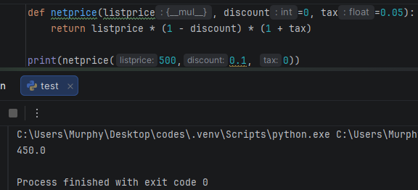
Little Exercise
Let’s create a counting program using default arguments.
import time
def count(start, end):
for x in range(start, end+1):
print(x)
time.sleep(1)
print("Done")
count(0, 10)

we don’t have to pass 0 as an argument assuming people always start from 0 when counting, so we are going to set the value of start as 0 making it default parameter.
import time
def count(start=0, end):
for x in range(start, end+1):
print(x)
time.sleep(1)
print("Done")
count(10)

But when try to run this code we get an error stating “parameter without a default follows parameter with a default”. If you are using any default arguments, you will want to be sure they are after any positional argument. We are going to put the parameter start=0 after the end parameter. After running the program, it is assuming that we would like to start from 0 but we will need to pass an ending amount, when we would like to stop counting?
import time
def count(end, start=0):
for x in range(start, end+1):
print(x)
time.sleep(1)
print("Done")
count(10)

But now, we have the option of starting at a different number that 0 something like 20 and ending at 40.
count(40, 20) #end at 40, start from 20
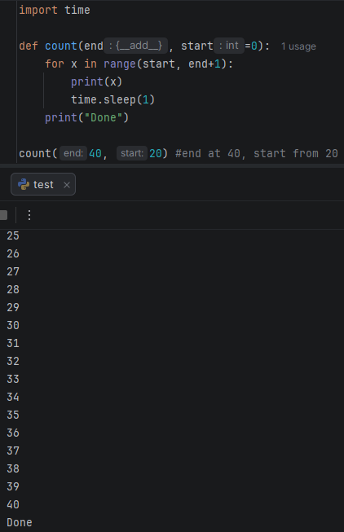

Keyword Arguments
Is an argument preceded by an identifier. It helps with readability and order of the arguments doesn’t matter if they are keywords.
Suppose we have a function to display a message like a greeting. We are going to name the function something like “Hello" and then open parenthesis and put 4 arguments inside of it something like; greeting, title, first_name, last_name. and then we are going to print it using f string. By doing this we are using the positional arguments, the position of these arguments does matter.
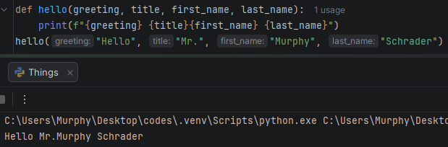
An optional feature when sending arguments to a function is that we could these into keyword argument. Prefix any arguments with the name of the perimeter, followed by equals ( = ).
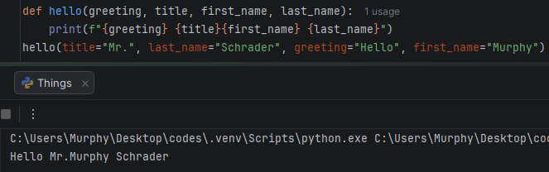
Although we changed the positions of the greeting, title, first_name, last_name but the output did not change. But make sure to put any positional argument first if it doesn’t have any keywords.
Let’s print the numbers 1 through 10 using fir loop:
for x in range(1, 11): #remember that the second number is exclusive that is why there is 11 instead of 10
print(x, end=" ")
The syntax end= is a keyword argument found within the built-in function. In place of ending each print statement with a new line, we are using end= and sending it to be a space.
Arbitrary Arguments
Varying amount of arguments. We don’t know how many arguments the user is going to pass in when they invoke a function. To accept a varying amount of arguments developers, tend to use *args and **kwargs.
*args = Allows you to pass multiple non-key arguments
**kwargs = Allows you to pass multiple keyword arguments
The * is unpacking operator.
def add(a, b):
return a + b
add(1,2)
print(add(1,2))

- *args
Suppose we have this code that is adding 1 and 2, and we want to add a third argument like number 3.
print(add(1,2,3)) We want to add 1, 2 and 3 and get the total of 6 but that wont work, because the add() function takes 2 positional arguments but three were given. We can modify the function so that it could accept a varying amount of arguments, any amount.
def add(*args)
we replaced the parameters with *args and when we use the unpacking operator *, what is going to happen is that the arguments that we pass into the function we will pack them all into a tuple.
def add(*args):
total = 0
for arg in args:
total += arg
return total
print(add(1,2,3,94))
Output = 100
Let’s try and pass some names:
def name(*args):
for arg in args:
print(arg, end=" ")
name("Abood”, ”Kendrick”, “George”)

We can add as many names as we want here.
- **Kwargs
It allows you to pass multiple keyword-arguments. This would be great for an address.
When you pass keyword arguments, it will pack them into a dictionary. Example:
def address(**kwargs):
for key, value in kwargs.items():
print(f"{key}: {value}")
address(street="Mohamed Dheere street 425", city="Kismayo", state="Jubaland", zip="0254")

Exercise
def shipping(*args, **kwargs):
pass
shipping("Mr.", "Murphy", "Sutherland", "Schrader",
street= "123 Fake St.", apt = "100", city = "Kismayo", state = "Jubaland", zip = "02521")

when we invoke this function, we have a mix of arbitrary positional arguments and arbitrary keyword arguments and this code it’s designed to accept both.
def shipping(*args, **kwargs):
for arg in args:
print(arg, end=" ")
print()
for value in kwargs.values():
print(value, end=" ")
shipping("Mr.", "Murphy", "Sutherland", "Schrader",
street= "123 Fake St.", apt = "100", city = "Kismayo", state = "Jubaland", zip = "02521")

what if we wanted to print the street and the apartment in one line and the city, state and the zip in another line?
def shipping(*args, **kwargs):
for arg in args:
print(arg, end=" ")
print()
print(f"{kwargs.get('street')} {kwargs.get('apt')}")
print(f"{kwargs.get('city')} {kwargs.get('state')} {kwargs.get('zip')}")
shipping("Mr.", "Murphy", "Sutherland", "Schrader",
street= "123 Fake St.", apt = "100", city = "Kismayo", state = "Jubaland", zip = "02521")

What if the user doesn’t have an apartment numbers? If removed the keyword apt = “100” the machine will print the following:
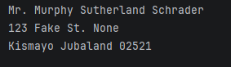
and we don’t want the program to print none next to the street. What we are going to do is to add and if and else statement. Example:
def shipping(*args, **kwargs):
for arg in args:
print(arg, end=" ")
print()
if "apt" in kwargs:
print(f"{kwargs.get('street')} {kwargs.get('apt')}")
else:
print(f"{kwargs.get('street')}")
print(f"{kwargs.get('city')} {kwargs.get('state')} {kwargs.get('zip')}")
shipping("Mr.", "Murphy", "Sutherland", "Schrader",
street= "123 Fake St.", city = "Kismayo", state = "Jubaland", zip = "02521")

After removing the apartment keyword from the code, we got this output:
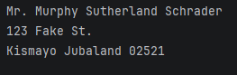
The program is no longer printing the none message when it did not detect the apartment keyword.
Iterables
An iterable it’s a category, any object or a collection that can return its elements one at a time is considered an iterable. If an object or a collection is considered iterable, then it can be iterated over in a loop.
Let’s say we have a list of numbers 1 through 5, lists are considered iterable we can use them within a for loop. Example:
numbers = [1,2,3,4,5]
for number in numbers:
print(number)
You could even iterate backwards, by enclosing our iterable within the reversed function.
numbers = [1,2,3,4,5]
for number in reversed(numbers):
print(number)
Now let’s cover sets. We will create a set fruit. Example:
fruits = {"apple", "banana", "cherry", "orange", "coconut"}
for fruit in fruits:
print(fruit)
For sets, its actually not reversible. You can’t reverse sets.
Now let’s cover strings. We will create a string of name. Example:
name = "Murphy S.Schrader"
for letter in name:
print(letter, end = " ")
Strings are reversible.
Lastly, let’s cover dictionary. Example:
dic= {"A": 1, "B": 2, "C": 3}
for key in dic:
print(key)

after running this code, we will get all keys A,B and C. if you want to only output the values write the following:
dic= {"A": 1, "B": 2, "C": 3}
for value in dic.values():
print(value)

If you want both the keys and the values, we are going to use the items method. Example:
dic= {"A": 1, "B": 2, "C": 3}
for key,value in dic.items():
print(key, value)

Membership Operators
They are the operators in and not in, they are used to test whether a value or a variable is found within a sequence, which include string, list, tuple, set or dictionary. Example:
word = "APPLE"
letter = input("Guess a letter in the secret word: ")
if letter in word:
print(f"there is a {letter}")
else:
print(f"{letter} was not found")

The in membership operator, will test to see if value or a variable is found within a sequence. In our case the in membership operator, checked for the letter Z in the sequence word and it did not find the letter Z within it, in this case the output will be the letter Z was not found.
The not in membership operator checks if there is not a letter or a variable found within a sequence. Example:

word = "APPLE"
letter = input("Guess a letter in the secret word: ")
if letter not in word:
print(f"{letter} was not found")
else:
print(f"there is a {letter}")

if the provided value or variable is not found within the sequence Word it returns true otherwise false.
So, it does the opposite of in.
Now let’s check for sets. Sets, tuples and lists behave the same. Example:
students = {"Murphy", "Sandra", "Michael", "John", "Samantha", "George", "Astor"}
search = input("Enter the name of the student: ")
if search in students:
print(f"{search} was found in the database.")
else:
print(f"{search} was not found in the database.")

Now let’s cover dictionaries.
grades = {"Sandy": "A", "Murphy": "A+", "John": "B-", "Codey":"C"}
search = input("Enter the name of a student: ")
if search in grades:
print(f"{search}'s grade is {grades[search]}")
else:
print(f"{search} was not found")

In order for us to get the values after the key we are just going to type: {grades[search]} or whatever you named your key.
List Comprehension
Is a concise way to create lists in python, they’re compact and easier to read than traditional loops. Follow this formular: (expressions for value in iterable if conditions) = for every value, is something that is iterable meaning you can loop through it, check some condition and the expression. Example of traditional loop:
dude = []
for x in range(1,11):
dude.append(x * 2)
print(dude)
So, this is a lot to write, we can use a list comprehension to make this code more compact and easier to read. Here how:
dude = [] #inside the empty list we are going to use this formular: expressions for value in iterable if conditions.
dude = [x * 2 for x in range(1,11)]
Print(“dude”)
Now we are going to work with strings, we are going to create list of fruits, and we need to make every value within the list of fruits uppercase. Example:
fruits = ["apple", "banana", "orange"]
fruits = [fruit.upper() for fruit in fruits]
print(fruits)

after running the code, the output will be uppercase for all of the fruits.
Now, let’s work with if conditions. We’ll create a list of numbers, both negative and positive. We’ll create a list comprehension to create a new list where all of the negative numbers are positive. Example:
numbers = [1, -2,3,-4,5,]
positive = [num for num in numbers if num >= 0]
print(positive)
Output = [1, 3, 5]
Negative Example:
numbers = [1, -2,3,-4,5,]
negative = [num for num in numbers if num < 0]
print(negative)
Output = [-2, -4]
Let’s check if there are even numbers:
numbers = [1, -2,3,-4,5,6,-7,8]
even = [num for num in numbers if num % 2 == 0]
print(even)
Output = [-2, -4, 6, 8]
Let’s check for odd numbers:
numbers = [1, -2,3,-4,5,6,-7,8]
odd = [num for num in numbers if num % 2 == 1]
print(odd)
Output = [1, 3, 5, -7]
Full code:
numbers = [1, -2,3,-4,5,6,-7,8]
positive = [num for num in numbers if num >= 0]
negative = [num for num in numbers if num < 0]
even = [num for num in numbers if num % 2 == 0]
odd = [num for num in numbers if num % 2 == 1]
print(positive, negative, even, odd, sep="\n")

Little Exercise
grades = [85, 42, 79, 90, 56, 61, 31, 99, 77, 60, 59, 100, 98, 66, 11, 67]
passing = [x for x in grades if x >= 60]
print(passing)
Output: [85, 79, 90, 61, 99, 77, 60, 100, 98, 66, 67]
Match-Case Statements (Switch)
Are alternative to using many else if (elif) statements. We execute some code if a value matches a case. The benefits of using Match-Case statements that they are cleaner and syntax is more readable. Example:
def week(day):
if day == 1:
return "It is Sunday"
elif day == 2:
return "It is Monday"
elif day == 3:
return "It is Tuesday"
elif day == 4:
return "It is Wednesday"
elif day == 5:
return "It is Thursday"
elif day == 6:
return "It is Friday"
elif day == 7:
return "It is Saturday"
else:
return "Invalid Input bitch"
print(week(1))

We got here if and else statements of days of the week, and instead of using else if statements we can use a cleaner and more readable alternative is Match-Case statements, instead of many else if statements. Here’s how: we are going to take our if and many else if statements and enclose them with within a match case block. Example:
The case is going to be the value we are examining: (match day:) we are going to examine our value of day against matching cases. We are going to replace if day == with the following:
def week(day):
match day:
case 1:
return "It is Sunday"
case 2:
return "It is Monday"
case 3:
return "It is Tuesday"
case 4:
return "It is Wednesday"
case 5:
return "It is Thursday"
case 6:
return "It is Friday"
case 7:
return "It is Saturday"
case _:
return "Invalid Input bitch"
print(week(1))

If you have an else clause, you are instead going to use case _: an underscore ( _ ) match case statement is a wild card, we will perform the last statement if there are no matching cases. The case _: will function as the else statement, which means there are no more statements to execute after it.
We tend to repeating ourselves a lot, the day’s Monday through Friday all return false. We are going to use the OR logical operator which is represented by ( | = OR Logical Operator).
def week_end(day):
match day:
case "Saturday" | "Sunday":
return True
case "Monday" | "Tuesday" | "Wednesday" | "Thursday" | "Friday":
return False
case _:
return False
print(week_end("Pizza"))

Variable Scope and Scope Resolution
Variable scope is where a variable is both visible and accessible.
Scope resolution when we’re using a variable there is a certain order know as (LEGB) rule in which we’ll locate that variable.
LEGB is abbreviated from: Local Enclosed Global Built-in.
Let’s begin with variable scope:-
We have two functions; funtion1 and function2 within function1, a = 1. And within function2 b = 2, if we invoke both of the functions, we would print 1 and 2. Variables declared within a function have a local scope, variable a is local to function1 and variable b is local to function2. Within function1 if we are to print b. and function2 if we were to print a, we would run into a name error.
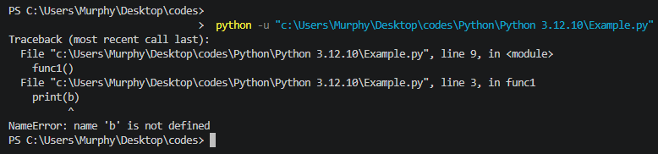
Functions can’t see inside of other functions. Imaging function1 is our house, we can see what is going on within our house, and function2 is our neighbor they can’t see what is going on inside of our house, function1 has no idea what is b, and function2 has no idea what is a. that’s where variable scope comes in. it’s where variable is visible and accessible.
Let’s rename a to be x, and b to be x as well, then we will print both of them.
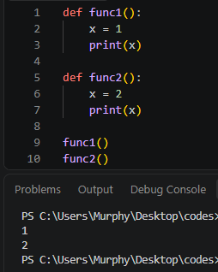
We have two version of x, a local one found within fuction1 and a local one found within function2, whenever we utilize a variable, we’ll first look to see if there is any local instance of that variable. If there isn’t, we we’ll move to the enclosed scope. Local Enclosed Global Built-in.
Within enclosed scope, one example is when you a function declared within another function. We’ll place function2 within function1. This is allowed in python; this is more advanced concept we’ll cover this in a future lesson.
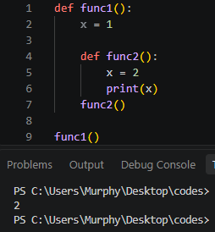
Within functiin2 if I was to print x, we would use the local version where x equals 2. If we were to eliminate the variable x = 2, we would use the enclosed version instead which is x = 1.
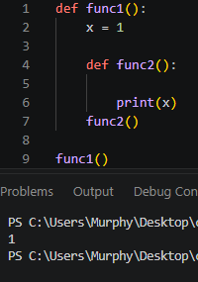
There is an order of operation, use any local variables first, then enclosed variables. We tried to print x within function2, since variable x = 2 wasn’t found, it printed x = 1 that was within function1.
Local Enclosed Global Built-in.
Global scope: Global meaning outside of any functions
def func1():
x = 1
print(x)

def func2():
x = 2
print(x)

func1()
func2()
we’ll eliminate the local variable declarations:
def func1():
print(x)

def func2():
print(x)

func1()
func2()
x = 3
we declared x = 3 outside of any functions, when we run the program, we are going to get 3 twice, once for function1 and once for function2.
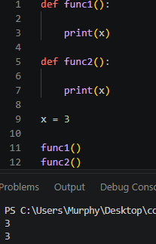

Built-in:
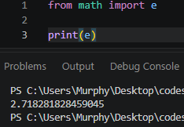
E is built-in. we’ll create a function to print e.
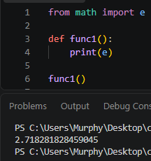
If we were to set e to a different value like 3, what we are doing technically is creating two different versions of e. variables can share the same name as long they’re with difference scope. We have a built in version of e that is found within the module e, and a global version that has the value of 3.
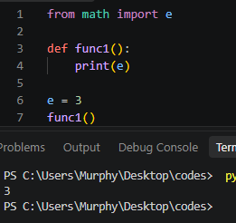
After printing e, we got the global one which is 3 instead of the built-in version. Why is that?
Because of the LEGB order, we will first look for a local version, and then enclosed version, and then global which we have and it is e = 3 and lastly built-in.
Slot Machine Program
import random
def spin_row():
symbols = ['🍒' ,'🍉', '🍋', '🔔', '⭐']
result = []
return [random.choice(symbols) for sym in range(3)]
def print_row(row):
print("*************")
print("| ".join(row))
print("*************")
def payout(row, bet):
if row[0] == row[1] == row[2]:
if row[0] == '🍒':
return bet * 3
elif row[0] == '🍉':
return bet * 4
elif row[0] == '🍋':
return bet * 5
elif row[0] == '🔔':
return bet * 10
elif row[0] == '⭐':
return bet * 20
return 0
def main():
balance = 100
print("******************************")
print("Welcome to Glory Slot Machine")
print("Symbols: 🍒 🍉 🍋 🔔 ⭐")
print("******************************")
while balance > 0:
print(f"Your current balance is ${balance:.2f}")
bet = input("Place your bet amount: ")
if not bet.isdigit():
print("Please enter a valid number")
print()
continue
bet = int(bet)
if bet > balance:
print("insufficiant Funds")
print()
continue
if bet <= 0:
print("Bet must be greater than 0")
print()
continue
balance -= bet
row = spin_row()
print("Spinning...\n")
print_row(row)
pay = payout(row, bet)
if pay > 0:
print(f"You won ${pay}")
else:
print("Sorry you lost this round")
balance += pay
again = input("Do you want to spin again? (Y/N): ").lower()
if again != "y":
break
print(f"Game over! Your balance is ${balance:.2f}")
if __name__ == '__main__':
main()

Message Encryption and Decipher Program
We’ll start by importing both the random module and the string module.
After importing the required modules, we are going to create a string of character, punctuation, and digits. Writing all of that will take a bit of time and there an easier way to get everything by writing the next code line:
chars = string.punctuation + string.digits + string.ascii_letters
print(chars)
This ensures a mix of punctuation, digits and both capital and small letters.
Output: !"#$%&'()*+,-./:;<=>?@[\]^_`{|}~0123456789abcdefghijklmnopqrstuvwxyzABCDEFGHIJKLMNOPQRSTUVWXYZ.
Now we are going to turn this the output string into a list, where each character is an individual element:
chars = string.punctuation + string.digits + string.ascii_letters
long = list(chars)
print(long)

and then we are going to create a key which we’ll shuffle eventually:
chars = string.punctuation + string.digits + string.ascii_letters
long = list(chars)
key = long.copy()
random.shuffle(key)
print(f"Chars: {long}")
print(f"Keys: {key}")
When somebody uses types some texts to be encrypted, we’ll replace every instance of one character within that string let’s say B, and we’ll replace it with something else. Example: John might become 039Gfjf>,:12”{}.
chars = string.punctuation + string.digits + string.ascii_letters
long = list(chars)
key = long.copy()
random.shuffle(key)
print(f"Chars: {long}")
print(f"Keys: {key}")
#Encryption
plain_text = input("Enter a message to encrypt: ")
cipher_text = ""
for letter in plain_text:
index = long.index(letter)
cipher_text += key[index]
print(f"Original Message: {plain_text}")
print(f"Encrypted Message: {cipher_text}")
and now we need to decrypt the message after encrypting it. Here how:

#Decryption
cipher_text = input("Enter a message to decrypt: ")
plain_text = ""
for letter in cipher_text:
index = key.index(letter)
plain_text += long[index]
print(f"Encrypted Message: {cipher_text}")
print(f"Original Message: {plain_text}")

Now we can Successfully Encrypt and Decrypt our messages freely. Heres the full code:
import random
import string
chars = " " + ' ' + string.punctuation + string.digits + string.ascii_letters
long = list(chars)
key = long.copy()
random.shuffle(key)
print(f"Chars: {long}")
print(f"Keys: {key}")
#Encryption
plain_text = input("Enter a message to encrypt: ")
cipher_text = ""
for letter in plain_text:
index = long.index(letter)
cipher_text += key[index]
print(f"Original Message: {plain_text}")
print(f"Encrypted Message: {cipher_text}")
#Decryption
cipher_text = input("Enter a message to decrypt: ")
plain_text = ""
for letter in cipher_text:
index = key.index(letter)
plain_text += long[index]
print(f"Encrypted Message: {cipher_text}")
print(f"Original Message: {plain_text}")

The Hangman Game Project
import random
words = ("apple", "orange", "banana", "coconut", "pineapple")
#dic of key: and a tuple ()
hangman_art = {0:(" ",
" ",
" "),
1:(" o ",
" ",
" "),
2:(" o ",
" | ",
" "),
3:(" o ",
"/| ",
" "),
4:(" o ",
"/|\\",
" "),
5:(" o ",
"/|\\",
"/ "),
6:(" o ",
"/|\\",
"/ \\")}
def display_man(wrong_guesses):
print("***********")
for line in hangman_art[wrong_guesses]:
print(line)
print("***********")
def display_hint(hint):
print(" ".join(hint))
def display_answer(answer):
print(" ".join(answer))
def main():
answer = random.choice(words)
hint = ["_"] * len(answer)
wrong_guesses = 0
guessed_letter = set()
is_running = True
while is_running:
display_man(wrong_guesses)
display_hint(hint)
guess = input("Enter a letter: ").lower()
if len(guess) != 1 or not guess.isalpha():
print("Invalid input")
continue
if guess in guessed_letter:
print(f"{guess} is already guessed")
continue
guessed_letter.add(guess)
if guess in answer:
for i in range(len(answer)):
if answer [i] == guess:
hint[i] = guess
else:
wrong_guesses += 1
if "_"not in hint:
display_man(wrong_guesses)
display_answer(answer)
print("YOU WIN!")
is_running = False
elif wrong_guesses >= len(hangman_art) - 1:
display_man(wrong_guesses)
display_answer(answer)
print("YOU LOST!, GameOver")
is_running = False
if __name__ == "__main__":
main()
Object Oriented Programming – OOP
An object is bundle of related attributes (variables) and methods (functions).
Attributes are similar to variables to describe what the object has. For example, when you look around what objects that are on your desk you might find your phone, a book or a headset, each of these objects can have different attributes to represent it. An attribute of the phone next to you could set to be version_num = 13, is_on = True is the phone turned on or not that’s another attribute.
Objects also have the capabilities to do things, they have methods which are functions that belonged to an object. Do not mix functions and methods because they are technically different.
Some action that these objects can perform, with a phone; you can make a call or receive a call, turn the phone on or turn the phone off, those all could be functions.
To create many objects, we’ll need to utilize a class.
A class is a type of blueprint used to design the structure and layout of an object. We need to design what our objects have, their attributes and what they can do their methods.
We will create a class of car: -
To construct a car, we need special method it’s called Constructor it works similar to a function.
class car:
def __init__(selfs):
we need the method above to create an object the double underscore it’s called Dunder and this method behaves similar to a function and we need to setup the parameters and self is already provided to us.
Self means: this object we’re creating now which is this car. So, what are some attributes a car should have? A model, a year, a color and if it for sale or not. To assign these attributes we’re going to access self.
Self.the name of the attribute = the model we received. E.g., self.model = model, self.color = color, self.year = year, and so on.
When we receive the name of a model, we will assign It to the object: self.model.
class car:
def __init__(self, model, year, color, for_sale):
self.model = model
self.year = year
self.color = color
self.for_sale = for_sale
Now, to construct a car object we need a unique name for this car, let’s say car1.
class car:
def __init__(self, model, year, color, for_sale):
self.model = model
self.year = year
self.color = color
self.for_sale = for_sale
car1 = car("RollsRoyce", 2011, "Black", False)
print(car1)
Output: <__main__.car object at 0x0000026AC7538D10>

after running this code what we’re given is the memory address of the car1 object where it’s located.
Instead of printing the object itself, we’re going to access on of the attributes found within this car. We will follow the name of the car1 with a dot ( . ), the dot it is known as the attribute access operator. E.g., car1.model.
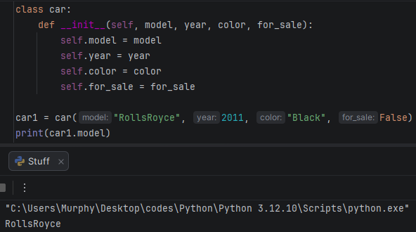
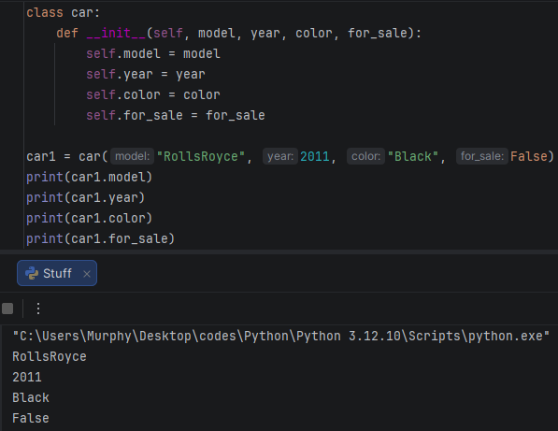
Let’s create a second car, we’re going to use the same class before to create a second car.
class car:
def __init__(self, model, year, color, for_sale):
self.model = model
self.year = year
self.color = color
self.for_sale = for_sale
car1 = car("RollsRoyce", 2011, "Black", False)
car2 = car("Corvette", 2016, "Red", True)
print("---First Car---")
print()
print(car1.model)
print(car1.year)
print(car1.color)
print(car1.for_sale)
print()
#Car 2
print("---Second Car---")
print()
print(car2.model)
print(car2.year)
print(car2.color)
print(car2.for_sale)
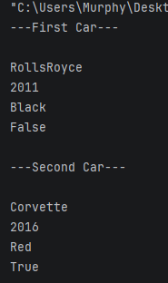
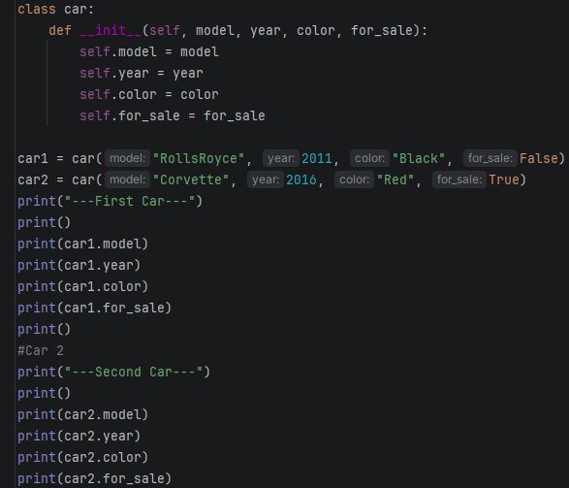
We used the same class to create 2 different cars, we can even create a third car, a fourth car and so on by only using one class.
With classes, they can tend to take a lot of a space, for better organization you can place them within a new python file and then import it. For example: from test import car.
Methods
Methods, are actions that our objects can perform. Within our class we’ll define a method of drive and self will be provided for us, when we invoke the drive function let’s print “You drive the car”. Example:
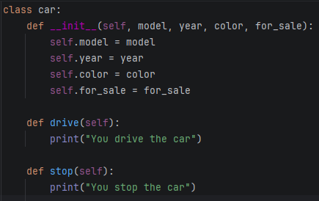
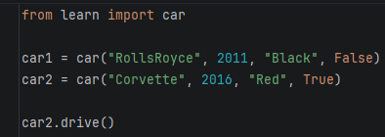
These methods are identical for each car object.
Instead of printing “print("You drive the car”)”, we’ll print the car model instead.
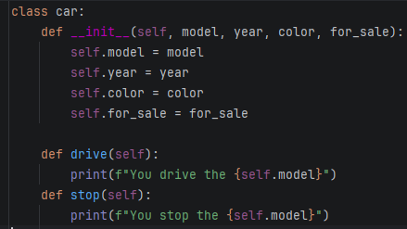

Self is referring to the object we’re currently working with, use the attribute access operator which is the dot ( . ) followed by the name attribute.
When we invoke, drive() we should get in the output: You drive the Corvette, you drive the car.
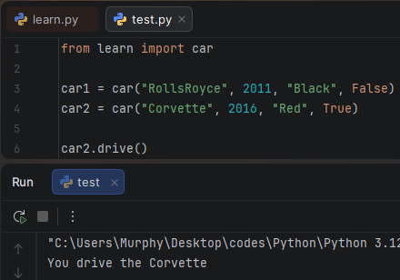
Note: I’m using the import method to make the code more readable.
Within our F string, we’ll insert the color.
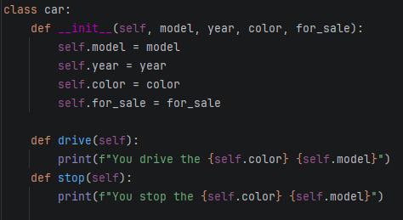
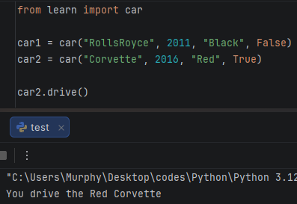
Let’s add one last method, the method will describe our car.
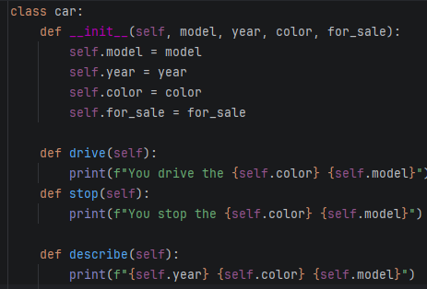
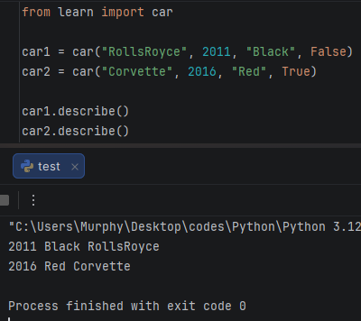
Those are objects in python, an object as a “bundle” of related attributes, attributes are variables that an object has. And methods are functions that belong to an object, they define what this object can do.
Class Variables
Class variables, are shared among all instances meaning objects, created from class.
Instance variables are defined inside the constructor, class variables are defined outside of the constructor with class variables they allow you to share data among all object created from that class.
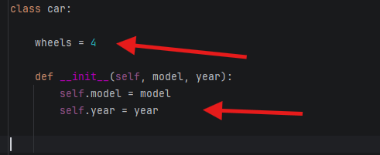
Instance Variables
Class Variables
With class variables, they allow you to share data among all objects created from that class.
With instance variables, each object has their own version. With a class variable, all those objects share one variable. Example:

class Student:
def __init__(self, name, age):
self.name = name
self.age = age
student1 = Student("Kendrick", 35)
student2 = Student("John", 29)
print(student2.name)
print(student2.age)

now we’ll create a class variable. Class variables, are defined outside of the constructor and they all shared among all objects created from that class. Each object has their own name and age attribute.
student1 = Student("Kendrick", 35)
student2 = Student("John", 29)
These are instance variables but class variables are defined outside the constructor each object will share this variable. Example:
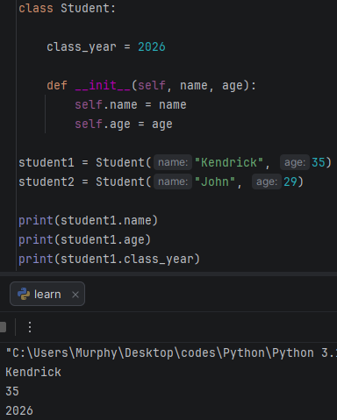
Both student1 and student2 can use the class_year = 2024.
Class variables, you can access them through anyone object such as student1 and student2. It’s good practice to access a class variable by the class name it helps with readability and clarity.
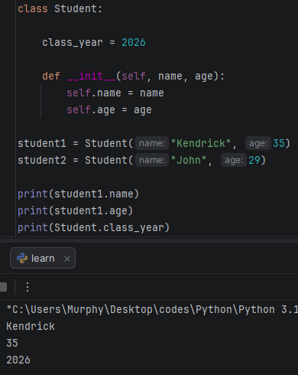
We are not using any instance to print the class year; we’re only using the class name itself to print the class year as shown on the picture.
We’re going to create a class variable with name: num_students to keep track the number of students.
Within our constructor, we can write any code that we want, this code will always be executed when we instantiate an object. We’ll take num_students, and increment it by 1 each time we construct a new student object.
Instead of using self., self refers to the object we’re currently working with if we’re constructing student1, just imaging we are placing self with student one or student2. If we’re modifying class variable, in place of self., we’ll use the name of the class which is Student, followed by a dot ( . ) which stands for; access our class of Student, get the num_students then we’ll increment it by 1.
class Student:
class_year = 2026
num_students = 0
def __init__(self, name, age):
self.name = name
self.age = age
Student.num_students += 1
student1 = Student("Kendrick", 35)
student2 = Student("John", 29)
print(Student.num_students)

we’re currently constructing two student objects, if we print the num_students it should be 2.
And to be sure let’s construct a third student object.
class Student:
class_year = 2026
num_students = 0
def __init__(self, name, age):
self.name = name
self.age = age
Student.num_students += 1
student1 = Student("Kendrick", 35)
student2 = Student("John", 29)
student3 = Student("Jimmy", "21")
print(Student.num_students)
Output: 3
Little Exercise:
class Student:
class_year = 2026
num_students = 0
def __init__(self, name, age):
self.name = name
self.age = age
Student.num_students += 1
student1 = Student("Kendrick", 35)
student2 = Student("John", 29)
student3 = Student("Jimmy", "21")
print(f"My graduating class of {Student.class_year} has {Student.num_students} Students")
print(student1.name)
print(student2.name)
print(student3.name)
Inheritance
Inheritance allows a class to inherit the attributes and methods from another class. By having a class inherit attributes and methods from another class, this helps with code reusability and extensibility.
In this lesson we are going to create an animal class where the dog, cat and a mouse will inherit attributes and methods from the animal class.
class Animal:
def __init__(self, name):
self.name = name
self.is_alive = True
def eat(self):
print(f"{self.eat} is eating")
def sleep(self):
print(f"{self.name} is sleeping")
we are going to create a class of Dog but for a child class to inherit the attributes and methods from another class, after the class name that is going to inherit, we need to an inheritance list with a set of parenthesis, then list the name of class we are inheriting from which is the parent in our case is Animal.
The dog class is going to inherit all of the attributes and methods of its parent Animal.
class Animal:
def __init__(self, name):
self.name = name
self.is_alive = True
def eat(self):
print(f"{self.eat} is eating")
def sleep(self):
print(f"{self.name} is sleeping")
class Dog(Animal):
pass

We are going to create the rest of the classes we need and then inherit attributes and methods from the parent class.
class Animal:
def __init__(self, name):
self.name = name
self.is_alive = True
def eat(self):
print(f"{self.name} is eating")
def sleep(self):
print(f"{self.name} is sleeping")
class Dog(Animal):
pass
class Cat(Animal):
pass
class Mouse(Animal):
pass
dog = Dog("Scoopy")
cat = Cat("Garfield")
mouse = Mouse("Mickey")
print(dog.name)
print(dog.is_alive)
dog.eat()
dog.sleep()
Even though the Dog, Cat and the Mouse classes are empty, they are still inheriting attributes from the Animal class, this is convenient because you do not have to copy and paste these attributes and methods for every single class.
Not only that our child classes can have their own attributes and methods, for example we are going to create a method of speak.
class Animal:
def __init__(self, name):
self.name = name
self.is_alive = True
def eat(self):
print(f"{self.name} is eating")
def sleep(self):
print(f"{self.name} is sleeping")
class Dog(Animal):
def speak(self):
print("WOOF")
class Cat(Animal):
def speak(self):
print("MEOW")
class Mouse(Animal):
def speak(self):
print("SQUEEK")
dog = Dog("Scoopy")
cat = Cat("Garfield")
mouse = Mouse("Mickey")
print(dog.name)
print(dog.is_alive)
dog.eat()
dog.sleep()
dog.speak()
That was introduction to inheritance in python, we learned that inheritance allows a class to inherit attributes and methods from another class much like in real life, a child can inherit traits from a parent, these also known as sub and Superclasses.

Multiple Inheritance and Multilevel Inheritance
Multiple Inheritance is that’s when a child class inherits from more than one parent class for example a class of C can inherit traits from both class A and B. in python, you can have more than one parent.
We are going to create two parent classes which they are: Prey and Predator and Child Classes which they are: Rabbit, Hawk, and Fish.
class prey:
def flee(self):
print("This animal is fleeing")
class predator:
def hunt(self):
print("This animal is hunting")
class Rabbit(prey):
pass
class Hawk(predator):
pass
class Fish(prey, predator):
pass
rabbit = Rabbit()
hawk = Hawk()
fish = Fish()
rabbit.flee()

Multilevel inheritance a parent can inherit from another parent. We’re going to create a class of Animal
Think of it like this; Rabbit, Hawk and Fish are the children’s classes, prey and predator are the parents of Rabbit, Hawk and Fish, and the Animal class is the grandparent. Prey and predator will inherit everything that the Animal class has, Rabbit, Hawk and Fish, will inherit everything the Prey and predator classes have. So now, our child classes have the ability to eat and sleep.
class Animal:
def eat(self):
print("This animal is eating")
def sleep(self):
print("This animal is sleeping")
class prey(Animal):
def flee(self):
print("This animal is fleeing")
class predator(Animal):
def hunt(self):
print("This animal is hunting")
class Rabbit(prey):
pass
class Hawk(predator):
pass
class Fish(prey, predator):
pass
rabbit = Rabbit()
hawk = Hawk()
fish = Fish()
rabbit.flee()
rabbit.eat()
rabbit.sleep()

Expanding the example:
class Animal:
def __init__(self, name):
self.name = name
def eat(self):
print(f"{self.name} is eating")
def sleep(self):
print(f"{self.name} is sleeping")
class prey(Animal):
def flee(self):
print(f"{self.name} is fleeing")
class predator(Animal):
def hunt(self):
print(f"{self.name} is hunting")
class Rabbit(prey):
pass
class Hawk(predator):
pass
class Fish(prey, predator):
pass
rabbit = Rabbit("bugs")
hawk = Hawk("Tony")
fish = Fish("Nemo")
rabbit.flee()
rabbit.eat()
rabbit.sleep()

Super() Function
Super() is a function that is used within a child class to call methods from a parent class, the child class is the subclass and the parent class is the super class. Using the super() function, it allows you to extend the functionality of the inherited methods. Example:
class circle:
pass
class Square:
pass
class Triangle:
pass

for each of these classes in order to instantiate and objects. We’ll need constructor.
class circle:
def __init__(self, color, filled, radius):
self.color = color
self.filled = filled
self.radius = radius
class Square:
def __init__(self, color, filled, width):
self.color = color
self.filled = filled
self.width = width
class Triangle:
def __init__(self, color, filled, width, height):
self.color = color
self.filled = filled
self.width = width
self.height = height
with programming, we try not repeat ourselves if we don’t have to, what do all of these classes have in common? They all share the attributes of color and filled. The ways in which they are different is that circle has a radius attribute, square has a width and triangle has both width and height. If we’ve to make any changes to one of these attributes, we’ll have to so manually if NOT refactoring, it’s better to write your code once and try reuse it. That’s where inheritance and the super() function come in handy. We’re going to take the attributes of color and filled and place it within a parent class, the children’s classes which are circle, square and triangle will inherit those attributes.
class shapes:
def __init__(self, color, filled):
self.color = color
self.filled = filled
class circle(shape):
def __init__(self, color, filled, radius):
self.color = color
self.filled = filled
self.radius = radius
class Square(shape):
def __init__(self, color, filled, width):
self.color = color
self.filled = filled
self.width = width
class Triangle(shape):
def __init__(self, color, filled, width, height):
self.color = color
self.filled = filled
self.width = width
self.height = height

We don’t need to manually assign the attributes color and filled within each of the constructors for the children, instead what we’ll have to do is within the constructor for each of the children’s classes, we’ve to call the constructor for the parent also known as Superclass. We’re going to eliminate the two codes fill and color from the children’s classes and use the super() function. Example:
class shapes:
def __init__(self, color, filled):
self.color = color
self.filled = filled
class Circle(shapes):
def __init__(self, color, filled, radius):
super().__init__(color, filled)
self.radius = radius
class Square(shapes):
def __init__(self, color, filled, width):
super().__init__(color, filled)
self.width = width
class Triangle(shapes):
def __init__(self, color, filled, width, height):
super().__init__(color, filled)
self.width = width
self.height = height
circle = Circle(color = "red", filled = True, radius = 5)
print(circle.color)
print(circle.filled)
print(f"{circle.radius}cm")

What you could do next is extend the functionality of a method. Example:
Within our shape class, let’s create a method of describe and we’ll describe the attributes of shape.
class shapes:
def __init__(self, color, filled):
self.color = color
self.filled = filled
def describe(self):
print(f"it is {self.color} and {'filled' if self.filled else 'not filled'}")

Each of the shapes, circle, square and triangle will’ve access to the describe method.
class shapes:
def __init__(self, color, filled):
self.color = color
self.filled = filled
def describe(self):
print(f"it is {self.color} and {'filled' if self.filled else 'not filled'}")
class Circle(shapes):
def __init__(self, color, filled, radius):
super().__init__(color, filled)
self.radius = radius
class Square(shapes):
def __init__(self, color, filled, width):
super().__init__(color, filled)
self.width = width
class Triangle(shapes):
def __init__(self, color, filled, width, height):
super().__init__(color, filled)
self.width = width
self.height = height
circle = Circle(color = "red", filled = True, radius = 5)
square = Square(color = "blue", filled = False, width = 7)
triangle = Triangle(color = "yellow", filled = True, width = 6, height = 8)
triangle.describe()
we also have method overriding. What if we create a similar method of describe within circle, square and triangle? Let’s do that:
class Circle(shapes):
def __init__(self, color, filled, radius):
super().__init__(color, filled)
self.radius = radius
def describe(self):
print(f"it is circle with an area of {3.14 * self.radius * self.radius}cm²")

if we were to call the describe method, will we use the parents’ version of describe or the child?
def describe(self):
print(f"it is circle with an area of {3.14 * self.radius * self.radius}cm²")
This is called method overriding if a child shares similar method with the parent, it will use the child’s version and not the parents. If you would like to extend the functionality of a method from a parent, you can use the super() function, not only we want to use the child’s describe method we would also want to use the parents describe method, so within the method, we’ll use the super() function.
def describe(self):
print(f"it is circle with an area of {3.14 * self.radius * self.radius}")
super().describe()
what we’re doing here is extending the functionality of the describe method and if we run the code we should get and output with both the parent’s describe method and the child’s describe method.

class shapes:
def __init__(self, color, filled):
self.color = color
self.filled = filled
def describe(self):
print(f"it is {self.color} and {'filled' if self.filled else 'not filled'}")
class Circle(shapes):
def __init__(self, color, filled, radius):
super().__init__(color, filled)
self.radius = radius
def describe(self):
print(f"it is circle with an area of {3.14 * self.radius * self.radius}")
super().describe()
class Square(shapes):
def __init__(self, color, filled, width):
super().__init__(color, filled)
self.width = width
class Triangle(shapes):
def __init__(self, color, filled, width, height):
super().__init__(color, filled)
self.width = width
self.height = height
circle = Circle(color = "red", filled = True, radius = 5)
square = Square(color = "blue", filled = False, width = 7)
triangle = Triangle(color = "yellow", filled = True, width = 6, height = 8)
circle.describe()
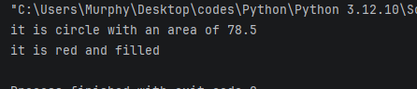
Output:

Polymorphism
Polymorphism is a programming concept it’s a Greek word that means to have many forms or faces.
Poly: Many
Morphe: Form
In programming, an object can take one many forms and there is two ways to achieve polymorphism:
- Inheritance = an object could be treated of the same type as a parent class.
- Duck typing = Object must have necessary attributes/Methods.
In this lesson we’re more focused on an Inheritance. Examples:
class Shape:
pass
class Circle(Shape):
pass
class Square(Shape):
pass
class Triangle(Shape):
pass
cicle = Circle()

we create a circle object, our circle identifies as a circle and since our circle class inherits from the shape class our circle is also considered shape, it has two forms it’s a circle and it’s a shape. But our circle isn’t a square or a triangle. Let’s say we’d like to create a list of shapes, what do they have all in common? Well, they’re shapes a descriptive name for this list would be “shapes” equals an empty list and we’ll instantiate a circle object, a square object and a triangle object.
shapes = [Circle(), Square(), Triangle()]
with our Shape class we’ll define an area method and we’re going to turn this into an abstract method. To work with abstract classes, we need import the following:
from abc import ABC, abstractmethod
preceding the area method, we’ll add a decorator of @abstractmethod. Our circle, square and triangle classes, they all are considered shapes, they inherit from the parent class Shape and we need to define an area method for each since they’re all considered a shape.
from abc import ABC, abstractmethod
class Shape:
@abstractmethod
def are(self):
pass
class Circle(Shape):
def __init__(self, radius):
self.radius = radius
def area(self):
return 3.14 * self.radius ** 2
class Square(Shape):
def __init__(self,side):
self.side = sid
def area(self):
return self.side ** 2
class Triangle(Shape):
def __init__(self, base, height):
self.base = base
self.height = height
def area(self):
return self.base * self.height * 0.5
shapes = [Circle(), Square(), Triangle()]

now we’ve to pass some arguments, for our circle we’ll need a radius which Is 4, for the square the length of the side will be 5, then our triangle the base will be 6 and the height will be 7, and then we’re going to write a loop to iterate through our shapes.
from abc import ABC, abstractmethod
class Shape:
@abstractmethod
def are(self):
pass
class Circle(Shape):
def __init__(self, radius):
self.radius = radius
def area(self):
return 3.14 * self.radius ** 2
class Square(Shape):
def __init__(self,side):
self.side = side
def area(self):
return self.side ** 2
class Triangle(Shape):
def __init__(self, base, height):
self.base = base
self.height = height
def area(self):
return self.base * self.height * 0.5
shapes = [Circle(4), Square(5), Triangle(6,7)]
for shape in shapes:
print(shape.area())

Duck Typing
Duck typing is another way to achieve polymorphism besides using inheritance. Objects can be treated as if they’re different types long as they meet the minimum necessary attributes/methods required of them. It follows this form: if it looks like a duck and quacks like a duck, it must be a duck.
As long as an object resembles another, it could also be treated of that type.
Example:
class Animal:
alive = True
class Dog(Animal):
def speak(self):
print("Woof")
class Cat(Animal):
def speak(self):
print("Meow")
class Car:
def horn(self):
print("Honk")
animals = [Dog(), Cat(), Car()]
for animal in animals:
animal.speak()

We’ve 3 classes; Dog, Cat and a Car. if we run this code, what do you think we’ll get? We’ll get the following: AttributeError: 'Car' object has no attribute 'speak', because our car object doesn’t have the minimum necessary attributes and methods. When iterating through this list of animals, we’re calling each animal speak method, which our car method doesn’t have but it does have a horn method so what if we renamed our horn to speak? We’ll this would work the dog goes woof, the cat goes meow and the goes honk. So, our car object it quacks like a duck we could consider it a duck, it has the minimum necessary methods to be considered an animal. Animals inherit the alive = True attribute, let’s utilize that.
class Animal:
alive = True
class Dog(Animal):
def speak(self):
print("Woof")
class Cat(Animal):
def speak(self):
print("Meow")
class Car:
def speak(self):
print("Honk")
animals = [Dog(), Cat(), Car()]
for animal in animals:
animal.speak()
print(animal.alive)
After running this code we’ll get an error that says: AttributeError: 'Car' object has no attribute 'alive', but if we where to add that the attribute alive = False to the Car class we would get False.
Our car, meets the minimum necessary requirements to be considered an animal.
7:33:34

Advanced Python
Lists
A list is created with square brackets [] and within these brackets you put each element you want separated by a comma. Example:
mylist = ["Hello World", "Kind Person", "The world is wonderful", "Apples"]
print(mylist)
we can also create a new empty list with the function list().
mylist = ["Hello World", "Kind Person", "The world is wonderful", "Apples"]
print(mylist)
mylist2 = list()
print(mylist2)

list allows for different data types for example we can say our list can contain integer, a Boolean and a string that’s all possible, and the list allows duplicate elements for example if you put apple twice in the list it will print it normally.
mylist2 = [5, True, "Apple", "Apple"]
print(mylist2)
Output: [5, True, 'Apple', 'Apple']
Now if you want to access an element within the list you can do that by referring to the index and the index start from 0, if you got a integer numbers starting from 1 to 10 in your list and want to print 4 for example, you can’t just type: print(mylist2[4])and expect it will print 4, instead It will print 5.
Example of how indexing works:
Integers | 1 | 2 | 3 | 4 | 5 | 6 | 7 | 8 | 9 | 10
Indexing | 0 | 1 | 2 | 3 | 4 | 5 | 6 | 7 | 8 | 9

mylist = ["Banana", "Apple", "Pineapple", "Carrot", "Coconut"]
item = mylist[0] , mylist[4], mylist[2]
print(item)
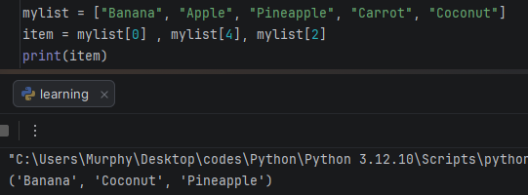
You can also do reverse indexing by just using negative before the integer example: -2 or -4, and that will give a reverse indexing of the fruits, for our case -2 will give us Carrot and -4 will give us Apple.
What happens if we typed -0? Which fruit will be printed? The Banana would printed also for -5 the Banana will be printed. Both -0 and -5 will work the same as long as the last element in negative indexing equals to 0 for the positive indexing.
You can iterate over your list with a for loop. Example:
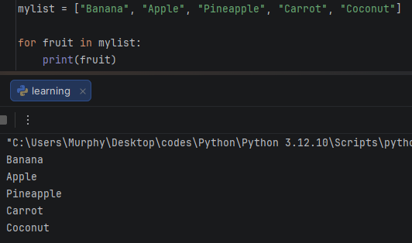
You can also iterate the words them selves for example, if you want the second letter of each word in the list you can get by just typing:
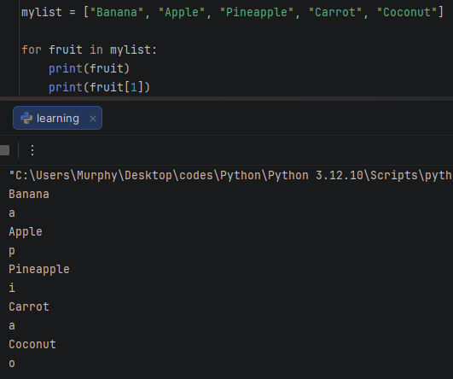
If you want to check if there is an item inside your list you can do it with if and else statements. Example:
mylist = ["Banana", "Apple", "Pineapple", "Carrot", "Coconut"]
if "Banana" in mylist:
print("Fruit is found within the list")
else:
print("Fruit was not found within the list")
Remember that Python is case sensitive, if you write Banana with all small letters, it will not detect it.
Another useful thing is that if you wanted how many elements is within your list you can use the length function. Example:
mylist = ["Banana", "Apple", "Pineapple", "Carrot", "Coconut"]
good = len(mylist)
print(good)
Output: 5
If wanted to add a new fruit to your list something like a lemon, you can the Append function. Example:
mylist = ["Banana", "Apple", "Pineapple", "Carrot", "Coconut"]
mylist.append("Lemon")
print(mylist)
Output: ['Banana', 'Apple', 'Pineapple', 'Carrot', 'Coconut', 'Lemon']
If every new appended element will always go in the last position of list, for our lemon it went in the last position of our list.
What if we wanted to add a new fruit but in a specific position? We can do that using the insert method. Example:
First specify which position you wish to insert your fruit for our case we wish to insert lemon before Banana. We would type: mylist.insert(position, “fruit name, or an element”)
mylist = ["Banana", "Apple", "Pineapple", "Carrot", "Coconut"]
mylist.insert(0, "Lemon")
print(mylist)
Output: ['Lemon', 'Banana', 'Apple', 'Pineapple', 'Carrot', 'Coconut']
If you wanted to remove an item you can do that with the pop method. But it will remove the last fruit or the last element of the list. Example:
mylist = ["Banana", "Apple", "Pineapple", "Carrot", "Coconut"]
item = mylist.pop()
print(item) #to see what Kind of item would be removed
print(mylist)
Output: ['Banana', 'Apple', 'Pineapple', 'Carrot']
You can also use the remove function to remove a specific element In the list. Example:
mylist = ["Banana", "Apple", "Pineapple", "Carrot", "Coconut"]
item = mylist.remove("Carrot")
print(mylist)
Output: ['Banana', 'Apple', 'Pineapple', 'Coconut']
Also, if you wanted to remove everything in the list you can use the clear function. Example:
mylist = ["Banana", "Apple", "Pineapple", "Carrot", "Coconut"]
item = mylist.clear()
print(mylist)

if you wanted to sort a list that contains a mix of positive numbers and negative numbers you can use the sort method. Example:
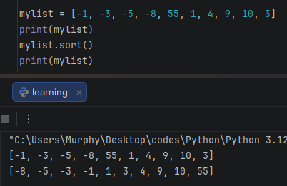
We can see everything have been sorted out.
Slicing
Slicing is a very nice way to access some parts of your list with the column ( : ). Example:
Suppose we’ve a list that contains an integers from 1 to 9, and we want to print only 2 to 5 and the rest not to be printed or ignored without manually having to remove them from the list.
mylist = [1,2,3,4,5,6,7,8,9]
a = mylist[1:6]
print(a)
Output: [2, 3, 4, 5, 6]
When we look what is inside a = mylist[1:6]we notice that we are trying to print 1 to 6, but the output is 2 to 6, why is that? Because as we mentioned earlier there is something called indexing which starts from 0 all the way up to the last digit, in our case number 1 has the index 0 and number 2 has the index 1, so we typed 1:6 but we only want 2 to 5 why there is a 6? Again that’s because of the indexing and also the last index is excluded meaning there will be deducted by only 1 index. That’s why we typed 6 instead of 5 because if we just typed 1:5 we only getting 4 indexing results instead of 5 index results.
There is a good trick to use and it’s called optional step which allows you to print the whole digits of the list from 1 to 9 without having to type [0:10].
mylist = [1,2,3,4,5,6,7,8,9]
a = mylist[::1]
print(a)
[::1] = Optional Step
Output: [1, 2, 3, 4, 5, 6, 7, 8, 9]
If you want to reverse the list just write [::-1]. This will reverse the whole list.
mylist = [1,2,3,4,5,6,7,8,9]
a = mylist[::-1]
print(a)
Output: [9, 8, 7, 6, 5, 4, 3, 2, 1]

Python for Cybersecurity
Logging
First the library is “Logging” it is a strong and powerful tool, and it is used to manage and track messages during program running. It offers advanced options to record events in detailed which makes it important to develop high-end programs.
The main levels in the Logging library are:
DEBUG: to record detailed information during program development.
INFO: to record general events like; performing specific tasks.
WARNING: to record warnings that indicates to probable problems but it is not dangerous.
ERROR: records errors that leads to not performing a specific task.
CRITICAL: to record fatal errors that leads to the program stopping or collapsing.
Scapy
It is an open-source library in python it is used to analyze packets and perform a group of wide tasks that is concerned with networks. It is used widely in penetration testing and cyber security like ARP spoofing and DNS Spoofing.
- What is the difference between DNS spoofing and ARP spoofing?

العنصر | DNS Spoofing | ARP Spoofing
المجال | Works on a wide side through network | Only works on Local Area Network (LAN)
Target/Goal | Trick users and direct them to wrong websites | Trick devices and direct the data to the attacker
Layer | Seventh Layer (Application Layer) | Second layer ( Data link Layer)
Damages | Steal information or inject malware | Intercept information or disable network

Table differentiates between DNS and ARP
Name | Abbreviation | Real example
Domain Name System | DNS | When you write www.google.com in the browser, it will be converted into an IP address like: 142.250.64.78
Address Resolution Protocol | ARP | Computer device trying to understand the MAC address of a router device to send data.
38:42

